**Amazon Books Insights: Trends in Genre, Pricing, and Reader Preferences**

**Analysis Insight**

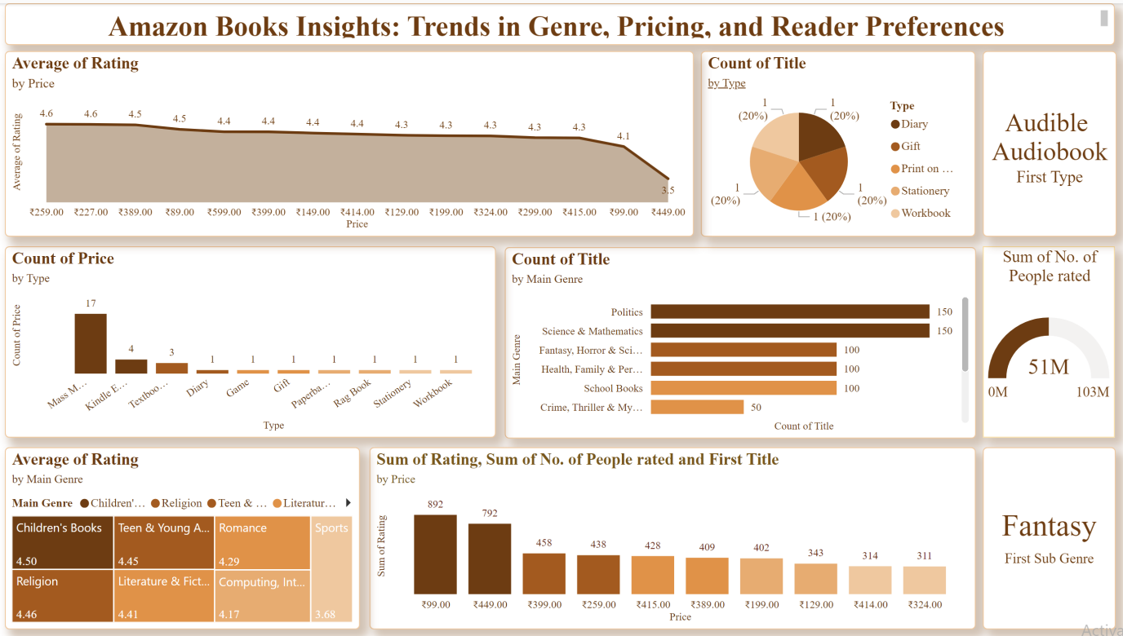

**Observations:**

**1. Average Rating by Price**

Books priced in the ₹89–₹199 range have the highest average ratings (4.5–4.6), suggesting that lower-priced books tend to meet reader expectations more effectively.

As prices increase (₹259 and above), there is a noticeable decline in average ratings, with books priced at ₹449 receiving the lowest average rating of 3.5.

The price range ₹324–₹399 maintains consistent ratings (4.4), indicating a sweet spot for moderately priced books.

**2. Count of Titles by Type**

The "Mass Market Paperback" format dominates with the highest number of titles (17), demonstrating its popularity as a widely accessible and affordable option for readers.

Other formats, such as "Kindle Editions" (4 titles) and "Textbooks" (3 titles), have significantly lower representation, highlighting the dominance of physical books over digital or specialty formats.

Niche formats like Diaries, Games, and Stationery are minimally represented, indicating limited demand or supply in these categories.

**3. Audible Audiobook Focus (Continued)**

The dedicated space for Audible Audiobooks suggests that audiobooks are becoming an increasingly popular format among readers.

This trend reflects the demand for alternative reading methods, especially among busy individuals or those who prefer listening over reading.

The limited data in this visualization indicates a need for further exploration into how Audible Audiobooks perform compared to other formats like eBooks or paperbacks.

**4. Count of Titles by Main Genre**

Genres such as "Politics," "Science & Mathematics," and "Fantasy, Horror & Science Fiction" have the highest number of titles (150 each), indicating a strong reader interest in these categories.

"Crime, Thriller & Mystery" and "Health, Family & Personal Development" are moderately represented, with around 50 titles, suggesting consistent but niche demand.

Less represented genres may indicate either a smaller audience or fewer offerings in those categories, highlighting potential growth opportunities for publishers.

**5. Count of Price by Type**

"Mass Market Paperbacks" exhibit the widest range of price points, demonstrating their adaptability to cater to various audience segments.

Digital formats like "Kindle Editions" have fewer price points, reflecting limited diversity in pricing or fewer offerings in this format.

Other types like Diaries, Gift Books, and Stationery are limited in both availability and price diversity, indicating that these are specialty items catering to niche markets.

**6. Average Ratings by Main Genre**

"Children's Books" lead with the highest average rating (4.50), indicating strong satisfaction among readers, likely due to well-curated content for a specific audience.

"Religion" (4.46) and "Teen & Young Adult" (4.45) also have high ratings, reflecting their appeal to loyal and engaged audiences.

Lower-rated genres like "Computing & Internet" (4.17) and "Sports" (3.68) may need improvement in content quality or presentation to better meet reader expectations.

**7. Sum of Ratings, Number of People Rated, and Price Relationship**

Books priced between ₹199 and ₹324 receive the highest engagement, with a significant number of ratings and reviews. This price range appears to balance affordability with perceived value.

Books priced above ₹449 show a dramatic drop in engagement, indicating that high prices deter many readers.

Titles in the lower price range (₹89–₹199) receive consistent ratings and engagement, reinforcing their accessibility to a broad audience.

**8. Total Number of People Rated (Gauge Visual)**

The total number of ratings is a staggering **51 million**, demonstrating Amazon's significant influence as a platform for book discovery and customer feedback.

High engagement across multiple genres and formats highlights a strong culture of readers actively reviewing and rating books.

**9. Fantasy as a Sub-Genre (Spotlight Visual)**

The specific emphasis on "Fantasy" indicates it is a high-performing sub-genre, either in terms of popularity, engagement, or sales.

Fantasy books often appeal to a loyal and passionate audience, making this genre a lucrative area for publishers to expand their offerings.

**Overall Observations**

**Pricing and Engagement**: Lower to mid-priced books (₹199–₹324) drive the highest ratings and engagement, suggesting this is the optimal price range for most readers.

**Genre Preferences**: Genres such as Politics, Science, Fantasy, and Children's Books perform exceptionally well in terms of availability and ratings, reflecting their broad appeal.

**Format Trends**: Physical books, particularly Mass Market Paperbacks, dominate both availability and pricing diversity, while digital formats like Kindle Editions remain underutilized. Audiobooks, though highlighted, may represent an emerging trend worth further exploration.

**Reader Engagement**: With 51 million ratings, reader participation on Amazon is robust, making it a critical platform for publishers to gauge audience preferences and feedback.

**Improvement Opportunities**: Genres with lower ratings (e.g., Computing, Sports) and underrepresented formats (e.g., Kindle, Textbooks) indicate areas where publishers can focus on improving quality or expanding offerings.

This dashboard effectively highlights trends but could benefit from deeper segmentation, such as exploring regional or demographic preferences, to further enhance insights.

**Recommendations:**

**1. Pricing Strategy**

**Target Optimal Pricing Ranges**:

Focus on pricing books in the ₹199–₹324 range, as this segment drives the highest engagement and maintains consistent ratings.

Avoid overpricing books beyond ₹449 unless they cater to niche markets or offer unique value, as engagement and satisfaction drop significantly in this range.

Experiment with dynamic pricing strategies for books in underperforming genres (e.g., Sports, Computing & Internet) to test whether reduced prices can attract more readers.

**Affordable Options for Wider Reach**:

Ensure sufficient representation of books priced below ₹199, as these consistently receive higher ratings and align with reader affordability.

**2. Format-Specific Focus**

**Expand Digital Offerings**:

Increase the availability of Kindle Editions and Audible Audiobooks, particularly for highly rated and popular genres like Children's Books, Religion, and Fantasy.

Offer introductory discounts or subscription-based pricing to boost adoption of digital formats among price-sensitive readers.

**Leverage Physical Books’ Popularity**:

Continue prioritizing Mass Market Paperbacks due to their dominance in title count and pricing diversity.

Explore hybrid offerings, such as bundled deals of physical books with free or discounted Kindle or Audible versions, to attract cross-platform users.

**Promote Audiobooks**:

Emphasize audiobooks as a growing segment by marketing their convenience to busy readers. Focus on genres like Crime, Thriller & Mystery, which align well with the audiobook format.

**3. Genre-Specific Recommendations**

**Capitalize on Popular Genres**:

Invest in creating more content for genres with high title counts and engagement, such as Politics, Science & Mathematics, and Fantasy, to maintain their market dominance.

Use these genres as anchors to introduce bundled promotions or recommendations for underperforming genres.

**Boost Low-Performing Genres**:

Address lower-rated genres like Sports and Computing & Internet by improving content quality, updating outdated material, or introducing engaging and practical formats.

Partner with influential figures (e.g., athletes for Sports books) to create appealing, authentic content that resonates with readers.

**Leverage Children’s Books and Religion**:

Focus on Children’s Books and Religion due to their consistently high ratings. Expand offerings, create visually appealing formats, and emphasize these genres in promotional campaigns.

**4. Reader Engagement and Feedback**

**Highlight Reader Reviews**:

Leverage the high volume of ratings (51 million) to spotlight top-rated books and testimonials in marketing campaigns. This helps build credibility and attract new buyers.

Introduce "Most Reviewed" or "Highest Rated" categories to make highly rated books more discoverable.

**Encourage More Reviews**:

Provide incentives for readers to leave reviews (e.g., discounts on their next purchase) for genres or formats with lower engagement, such as Textbooks or Sports.

**5. Strategic Promotions**

**Genre-Specific Campaigns**:

Conduct promotions for high-demand genres like Fantasy, Horror & Science Fiction, leveraging their strong readership.

Offer discounts or special bundles for niche genres (e.g., Health & Personal Development) to expand readership and market presence.

**Cross-Selling Opportunities**:

Use popular formats (Mass Market Paperbacks) to cross-sell less popular ones (e.g., Kindle Editions). For instance, offer Kindle Editions at a discounted price with a paperback purchase.

**Seasonal and Thematic Promotions**:

Use seasonal campaigns (e.g., back-to-school for Textbooks, holidays for Children’s Books) to increase visibility and sales in targeted categories.

**6. Enhance Discoverability**

**Improve Categorization**:

Ensure books are accurately categorized into sub-genres to enhance their discoverability. For example, Fantasy books should be further segmented into subcategories like Epic Fantasy or Urban Fantasy.

Use customer browsing and purchase data to recommend relevant books across similar sub-genres.

**Boost Visibility of Underrepresented Categories**:

Create featured sections for niche formats (Diaries, Games, Stationery) or lesser-known genres to drive curiosity and potential sales.

**7. Quality Improvement for Underperforming Genres**

**Address Content Issues**:

Work with publishers to enhance content quality in lower-rated genres like Sports and Computing. This could include more practical examples, up-to-date material, or engaging visuals.

Solicit reader feedback on what improvements they’d like to see and incorporate them into future editions.

**Use Data-Driven Insights**:

Analyse detailed reader feedback and trends for these genres to identify specific pain points, such as complexity, irrelevance, or lack of engaging narratives.

**8. Foster Emerging Trends**

**Promote Fantasy Sub-Genre**:

As Fantasy receives special attention in the dashboard, increase investment in this sub-genre by publishing more titles and enhancing marketing efforts.

Partner with popular authors or develop series to capitalize on the genre's loyal and growing reader base.

**Support Audiobooks as a Growth Segment**:

Highlight Audible Audiobooks in marketing campaigns, focusing on convenience for commuters or multitaskers.

Provide free trials or discounted first purchases to encourage adoption.

**9. Regional and Demographic Segmentation**

**Localized Offerings**:

Analyse regional preferences to tailor offerings, especially for high-performing genres like Religion or Children’s Books, which may have strong cultural influences.

Ensure titles in different languages and localized content are readily available.

**Demographic-Specific Strategies**:

For Teen & Young Adult books, focus on engaging formats like graphic novels or interactive eBooks.

For older demographics, prioritize large-print paperbacks and audiobooks for ease of consumption.

**10. Monitoring and Iteration**

**Track Performance Metrics**:

Continuously monitor ratings, sales, and engagement trends for different genres, formats, and price ranges. Use this data to refine strategies.

Incorporate A/B testing to experiment with new pricing models, promotional campaigns, or product categories.

**Feedback Loop**:

Actively gather customer feedback on the browsing and purchasing experience, including recommendations for additional features like curated book lists or enhanced audiobook previews.

**Conclusion**

By adopting these recommendations, publishers and sellers can optimize pricing, diversify formats, expand popular genres, and tap into underexplored opportunities. Leveraging Amazon’s vast reader engagement data will be crucial in shaping targeted, effective strategies that drive satisfaction, loyalty, and revenue growth.

### .